Macintosh HD:Users:David:Documents:Boston Sinfonia:Sinfonia Logos:New Logo.wmf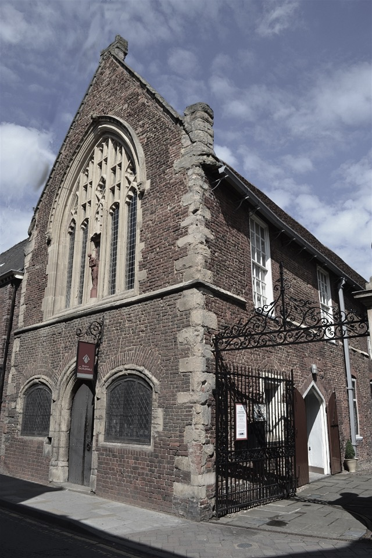

**Boston Guildhall Sunday 25th November**

**at 3.00pm**

***Mozart - Ballet Music from Idomeneo***

***Mozart - Horn Concerto No 4***

***Soloist – Susan Shorland-Compton***

***Mozart - A Musical Joke (Finale)***

***Mozart – Symphony No 40***

Tickets £10 from Stump Gift Shop (10-3.30 Mon-Sat)

online at www.bostonsinfonia.org.uk

and £12 on the door; under 18s free

(it is advised to book early due to limited seating)