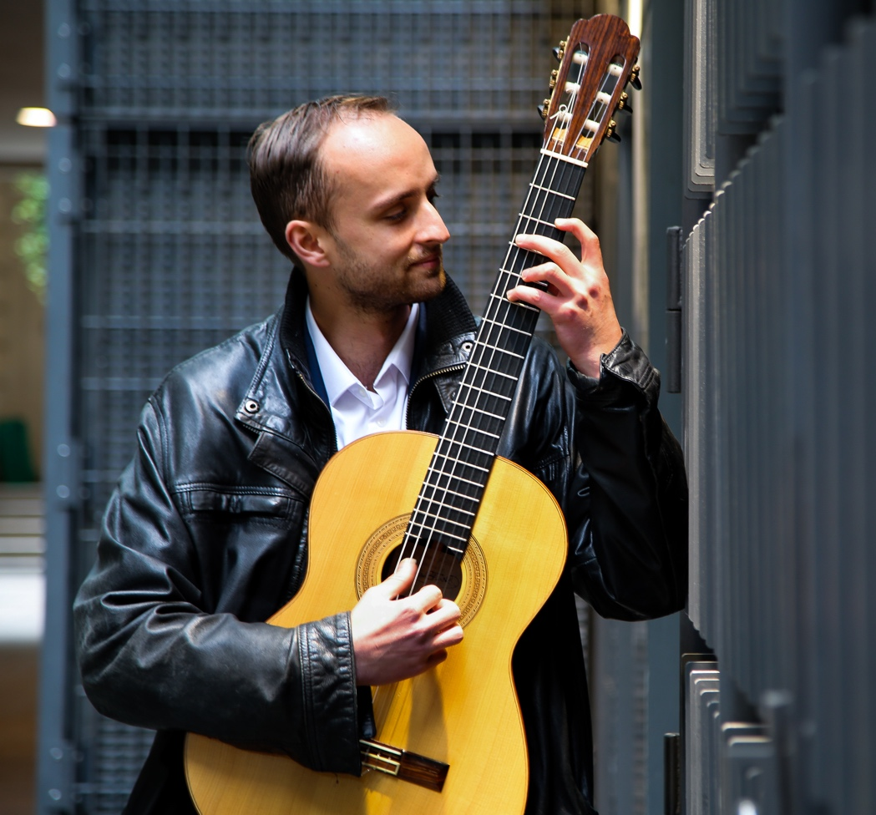
TOM GAMBLE

Tom Gamble is an award winning young classical guitarist who is rapidly gaining a reputation internationally as an exciting and versatile artist. Born in the suburbs of London UK, he began performing from age 13 where he was inspired and encouraged at a local festival held by famed Australian steel string guitar virtuoso Tommy Emmanuel. He quickly developed an impressive guitar technique and understanding for music, arrangement and composition. Throughout his youth he continued to perform frequently, often opening concerts for internationally renowned artists such as Martin Taylor and leading various ensembles and projects.
Tom studied at Trinity Laban Conservatoire of Music in London under tuition of Graham Anthony Devine. While at Trinity he was awarded first place in the “Gladys Puttick Improvisation Competition” adjudicated by Errollyn Wallen and Pete Churchill. He graduated in 2014 with a Bachelor of Music (with Honours) degree. Subsequently he was awarded a scholarship to continue his studies in Canada at the University of British Columbia under tuition of Dr Daniel Bolshoy. He graduated in the spring of 2016 with a Master of Music degree.

Tom has performed extensively throughout Europe and North America including the Queen Elizabeth Hall (with the London Philharmonic Orchestra in “Debut Sounds”), The London Guitar Festival, Cheltenham Jazz Festival, The 2012 Olympic Games, The London Acoustic Guitar Show, Ronnie Scotts Jazz Club, The Vancouver Orpheum and many more. He has performed several concerti including Rodrigo’s “Concierto de Aranjuez”, Ponce’s “Concierto del Sur” and Richard Harvey’s “Concerto Antico”. He is also an active performer of chamber music, and has appeared in numerous highly acclaimed ensembles.
Tom was first prize winner at the 2016 Northwest Guitar Competition in the USA. His live shows have been described as “intense, exciting, spontaneous and engaging”. His performances are also noted for their relaxed style and informative and entertaining spoken introductions.

